SE Lab External Final Exam

Student Name: Sahil Kaundal UID: 21BCS8197

Branch: CSE (Lateral Entry) Section/Group:20BCS-807_B Semester: 4th Date of Performance: 20/05/2022

Subject Name: SE Lab Subject Code: 20CSP-255

Q1.

1. Aim/Overview of the practical:

Design a Sequence and collaboration diagram of an Online Exam System

1. Task to be done/ Objective:



* Sequence diagrams are used to represent message flow from one object to another object.
* Sequence diagrams are used to explore any real application or a system.
* The collaboration diagrams are better suited for depicting simpler interactions of the smaller number of objects.
* Collaboration diagrams are used to understand the object architecture of a system rather than message flow.
* The objective of “Online Exam System” is to completely automate the old manual procedure of conducting exam to a computerized System.
* The system will allow students to register and take the exam. It enables also lecturers to perform many tasks. The system has several functions. The users will do the registration before using the system. The lecturers can upload questions and answers; he can view the list of all students who take the exam. He can view the list of students who have grade A, grade B, grade C, grade D and those who fail the exam. The lecturers can send emails. Once logging, the students can choose the subject and take the exam. After finishing using the software, the users have a logout function that allows them to sign out. This is because the system wants to ensure no external users can exploit the system.

1. Requirement Analysis:

Software Requirement:

* Smart Draw
* Google Chrome
* Operating System: Windows 7/8/10/11
* SQL
* Visual Studio Code
* Microsoft Azure Enterprises

Hardware Requirement:

* Computer
* Windows 10
* Power Supply
* System: Intel Core i3 7th Gen and above
* Hard Disk: 120 GB
* Monitor: 14’’ LED
* Input Devices: Keyboard, Mouse
* Ram: 4 GB
* Cloud Server

1. Features: -

* **Exam Scheduling and Planning**
* **Configuring different type of questions**
* **Instant Result Evaluation**
* **Result Analysis and Dashboards**
* **Important alerts**

1. Advantages:

* They are secure, customizable, reliable, highly interactive, reduced turnaround time and accessible via various devices.
* Online testing is an objective and systematic evaluation of human abilities, skills, behaviour’s / characteristics, etc.
* These assessments take place over the internet using available web technologies.
* Online testing has become increasingly popular in these areas: education, government and corporate companies.

1. Disadvantages:

* Challenges in Technology Adoption
* Infrastructural Barriers
* Difficulty in Grading Long-answer Type
* Susceptible to Cheating
* Transitioning to Open-Book Exams

1. Sequence Diagram:

A Sequence Diagram is an interaction diagram that details about the operation that is carried out. The sequence diagram captures the interaction between the objects in the context of collaboration. Sequence diagrams are time focused and they show the order of the interaction visually by using the vertical axis of the diagram to represent time.

1. Collaboration Diagram:

**Collaboration Diagram** represents the interaction of the objects to perform the behaviour of a particular use case or a part of use case. The designers use the Sequence diagram and Collaboration Diagrams to define and clarify the roles of the objects that perform a particular flow of events of a use case.

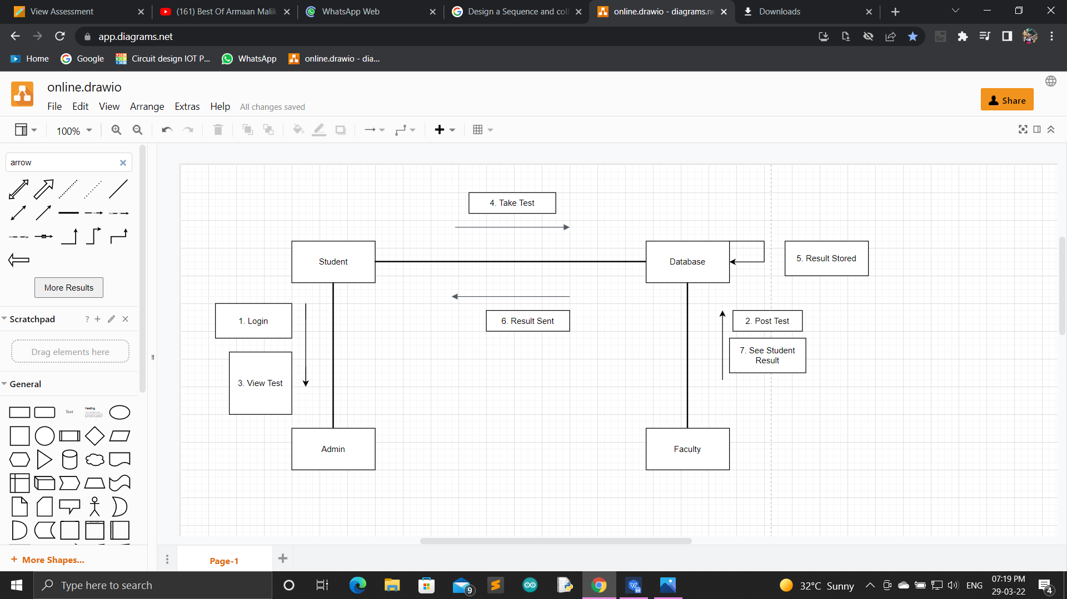

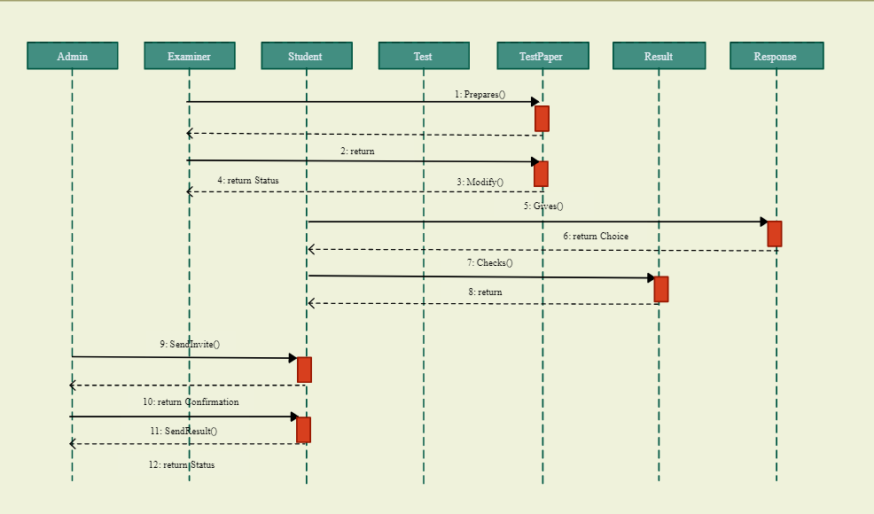

1. Result/Output/Writing Summary:

I have successfully done this practical.

Evaluation Grid (To be created as per the SOP and Assessment guidelines by the faculty):



|  |  |  |  |
| --- | --- | --- | --- |
| Sr. No. | Parameters | Marks Obtained | Maximum Marks |
| 1. |  |  |  |
| 2. |  |  |  |
| 3. |  |  |  |
|  |  |  |  |